IT INFRASTRUCTURE MODERNIZATION PROPOSAL (CLOUD MIGRATION PROJECT)
Prepared By: Rishi Bakliwal
B.Tech – Information Technology
India

1. Problem Statement
A mid-sized organization currently operates on a legacy on-premise IT infrastructure. The environment suffers from limited scalability, security vulnerabilities, high maintenance cost, manual backups, and frequent downtime. The company needs to modernize its infrastructure by migrating core services to a cloud environment.

2. Project Objectives
- Assess the existing IT infrastructure
- Identify modernization gaps
- Design a secure and scalable cloud architecture
- Prepare a phased cloud migration roadmap
- Define risks and mitigation strategies
- Improve backup, disaster recovery, and monitoring capabilities

3. Scope of Work
- Infrastructure assessment
- AS-IS and TO-BE documentation
- Cloud architecture design
- IAM, networking, compute, storage planning
- Migration execution plan
- Risk assessment
- Final proposal documentation

4. AS-IS Architecture
Current on-prem environment includes:
- Physical servers hosting applications
- Local MySQL database
- File server with no redundancy
- Manual data backup on external drives
- No centralized monitoring or alerting
- LAN-based access to services
- Single-point-of-failure storage
- Basic firewall with limited rules

AS-IS Architecture Diagram
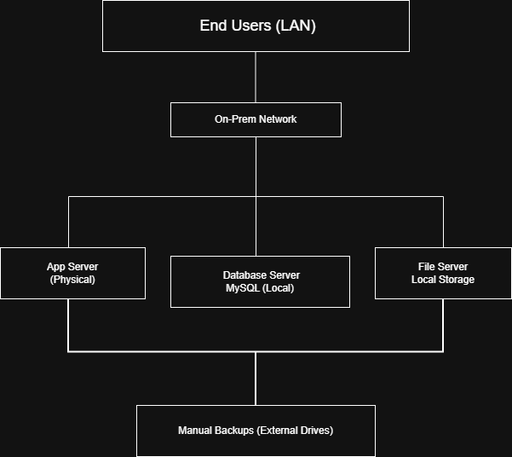

5. TO-BE Cloud Architecture
Target cloud environment includes:
- Cloud VM instances for applications
- Managed SQL database
- Object storage for file hosting
- VPC with public/private subnets
- IAM & role-based access control
- Cloud monitoring & central logging
- Automated daily backups
- Multi-zone high availability

TO-BE Cloud Architecture Diagram
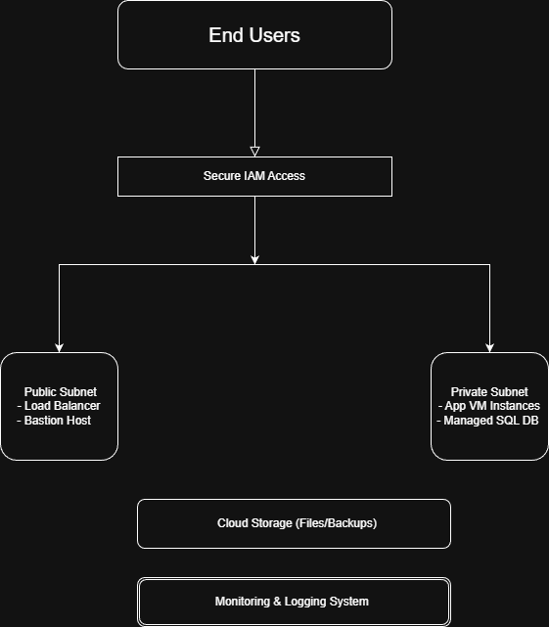

6. Requirement Analysis

Functional Requirements
- Host applications on scalable VMs
- Provide secure remote access
- Enable centralized document storage
- Maintain automated daily backups
- Ensure 99.9% uptime availability

Non-Functional Requirements
- Scalability
- Security & access control
- Disaster recovery capability
- Cost optimization
- Performance monitoring

7. Migration Plan

Phase 1 — Assessment
- Inventory existing servers
- Identify dependencies
- Evaluate network & storage requirements

Phase 2 — Preparation
- Set up VPC, subnets, firewall rules
- Configure IAM roles
- Prepare cloud storage buckets
- Establish secure connectivity (VPN/SSH)

Phase 3 — Migration
- Migrate applications to cloud VMs
- Export & import database into Managed SQL
- Sync local file server → Cloud storage
- Update DNS and endpoints

Phase 4 — Testing
- Application functional testing
- Load testing
- Security validation
- Failover simulation

Phase 5 — Optimization
- Autoscaling setup
- Cost monitoring configuration
- Access audit & least-privilege enforcement

8. Risk Assessment
Risk | Impact | Mitigation
Data Loss | High | Automated backups, DR replication
Downtime During Migration | Medium | Blue/green deployment
Misconfigured IAM | High | Access reviews, least privilege
Cost Overruns | Medium | Budgets, alerts, monitoring
Security Gaps | High | Firewall, MFA, encryption

9. Tools Used
- Documentation: MS Word, PowerPoint
- Diagrams: draw.io
- Cloud Concepts: AWS / Azure / GCP (generic architecture)
- Database: Cloud SQL (conceptual)
- Research & Planning: Excel, Google Sheets

10. Conclusion
This project provides a comprehensive and structured approach to modernizing a legacy on-premise IT infrastructure through cloud migration. By evaluating the existing environment, identifying key risks, and designing a secure, scalable, and resilient TO-BE architecture, the proposal ensures improved system reliability, performance, and operational efficiency.
The phased migration plan minimizes downtime and ensures smooth transition of applications, databases, and storage to the cloud. With enhanced monitoring, automated backups, IAM-based security, and disaster recovery mechanisms, the organization can achieve long-term scalability, reduced maintenance overhead, and robust protection against security threats.
Overall, this modernization proposal demonstrates a complete end-to-end understanding of cloud transformation and serves as a strong foundation for implementing real-world digital infrastructure upgrades.

